ELCT 302
Laboratory Report #2
Model Identification
Group #2b (Steering Group)
November 7th, 2023

I hereby certify that I have complied
with the Spirit and the Letter
of the Carolinian Creed
in preparing this report

___________________________________________
Madelyn L. Hines

___________________________________________
Jacob C. Vaught

Department of Electrical Engineering
University of South Carolina
Columbia, SC 29208

Abstract
This lab report delves into the modeling and control of a steering system for a remote-controlled car by implementing a real-time system. The objective was to design circuitry to perform a step response of the servo motor, record relevant data, estimate the transfer function, and compare simulated outcomes with actual results. The experiment utilized a DC servo motor, operated under certain specifications such as voltage and communication frequency. Various modeling techniques were employed, including a time delay system, to estimate the system's behavior. The estimated transfer function was validated against actual system responses to ascertain its accuracy. The findings from this lab could be instrumental in the development of efficient and reliable control systems for steering mechanisms in automated vehicles.
Table of Contents
I. Introduction 3
II. Theory 3
A. DC Motor Theory 3
B. Transfer Function 4
C. Transfer Function Estimation 5
D. Ackerman Steering 6
E. Bicycle Model 7
F. Vehicle Dynamic’s Transfer Function 8
III. Experimental Procedure 10
A. Servo Motor Model Identification 10
B. Dynamic Steering Frame 11
IV. Discussion/Results 12
A. Servo Motor Model Identification 12
B. Dynamic Steering Frame 17
V. Conclusions 20
A. Servo Motor Model Identification 20
B. Dynamic Steering Frame 20
VI. Appendix 21
A. MATLAB code for Task 1 21
B. MATLAB Code for Task 2 22
C. MATLAB code for Pade 24
VII. References 26

Laboratory 2: Motor Identification

I. Introduction
This lab aims to accomplish several interconnected objectives that fall under two primary categories: servo motor step response modeling and dynamic steering frame estimation. The first objective focuses on designing a circuit to execute a unit step response test on a standard DC servo motor, facilitating data collection for the transfer function estimation via MATLAB. The second part aims to delve into dynamic steering frame theories, specifically the Ackerman steering system and the bicycle model, which requires the team to estimate parameters like mass, center of mass, and moment inertia.
Both topics hold substantial relevance in the realm of engineering applications. Understanding the servo motor’s behavior is essential for advanced control design, particularly in steering systems. Likewise, insights onto dynamic steering frames are crucial for creating stable and responsive control systems. These are both pertinent in understanding where precise control and reliable models are essential for safety and efficiency.

II. Theory

DC Motor Theory
DC motors convert electrical to mechanical energy via electromagnetic interactions, governed by the Lorentz force equation:
$$\begin{aligned}F=q\left(E+v×B\right) \#\left(1\right)\end{aligned}$$
The fundamental components of a DC motor include:
- Stator: Creates a magnetic field, either through a permanent magnet or windings.
- Rotor (or Armature): Contains a winding or loop.
- Commutator: A split ring reversing current direction for continuous rotation.
- Brushes: Provide electrical connections to the armature.
The operation is based on the electromagnetic principle where a conductor in a magnetic field experiences a force, given by:
$$\begin{aligned}F = I ⋅L ×B\#\left(2\right)\end{aligned}$$
Where F is the force, I is the current, L is the conductor length, B is the magnetic field. Current through the armature generates a force, creating a rotor torque. The commutator ensures continuous rotation by reversing current direction when the armature passes the magnetic neutral axis. Speed control in DC motors is achieved by varying terminal voltage or field current, as per the relation
$$\begin{aligned}N ∝\frac{V}{Φ}\#\left(3\right)\end{aligned}$$
where N is the motor speed, V is the voltage, $Φ$ is the magnetic flux. The figure explaining how DC Servo motors work is shown in Figure 1.
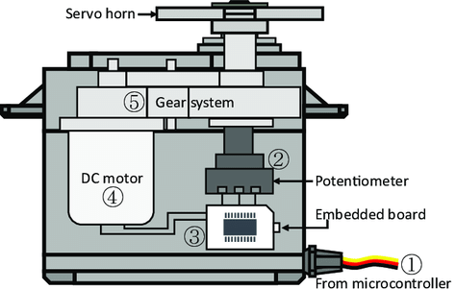
Figure 1 is a diagram of a servo motor system and its components

Transfer Function
The core concept behind modeling a DC servo motor relies on deriving its transfer function, $G(s)$. In the Laplace domain, the transfer function is the mathematical representation of the relationship between the input voltage $V(s)$and the output angular velocity $ω(s)$.
$$G\left(s\right)=\frac{ω\left(s\right)}{V\left(s\right)} =\frac{K}{\left(Js+B\right)\left(Ls+R\right)} + K^{2}$$
Here, $J$ is the moment of inertia of the rotor, $B$ is the damping ratio, $L$ is the inductance, $R$ is the resistance, and $K$ is the motor constant. The Laplace variables $s$ accounts for both the transient and steady-state behavior of the system. This equation serves as the starting point for all control system design for the DC servo motor.
To achieve desirable motor performance characteristics, such as minimal overshoot, fast settling time, and zero steady-state error, different control strategies are employed. In proportional control, the control effort is directly proportional to the error signal e(t) . The proportional gain $K_{p}$ adjusts the magnitude of the control action. The corresponding closed-loop transfer function for a system under P-control would be:
$$T\left(s\right)= \frac{K⋅K_{p}}{\left(Js+B\right)\left(Ls+R\right)+ \left(K^{2}+ K⋅K_{p}\right)}$$
P-control is often the simplest to implement but may not be sufficient for systems requiring zero steady-state error or improved transient performance. PI control not only corrects the present error but also accumulates past errors to eliminate steady-state error. This makes the system more robust to disturbances and model uncertainties. Its Laplace representation is:
$$T\left(s\right)= \frac{K⋅\left(K_{p}s + K_{i}\right)}{s\left(\left(Js+B\right)\left(Ls+R\right) + K^{2}\right)+K(K_{p}s+K_{i} )}$$
PID control, the most comprehensive among the three, includes a derivative term to predict future error and thereby improve the transient response. The closed-loop transfer function under PID control becomes:

$$T\left(s\right)= \frac{K⋅\left(K_{p}s^{2}+ K_{i}s + K_{d}\right)}{s^{2}\left(\left(Js+B\right)\left(Ls+R\right)+ K^{2}\right)+s\left(K⋅K_{d} + \left(Js+B\right)K_{p}\right)+\left(K⋅K_{i}+\left(Js+B\right)⋅K_{d}\right)}$$
This control strategy is particularly useful when the system is complex and requires fine-tuning on multiple performance criteria. An example of a PID Control system is below

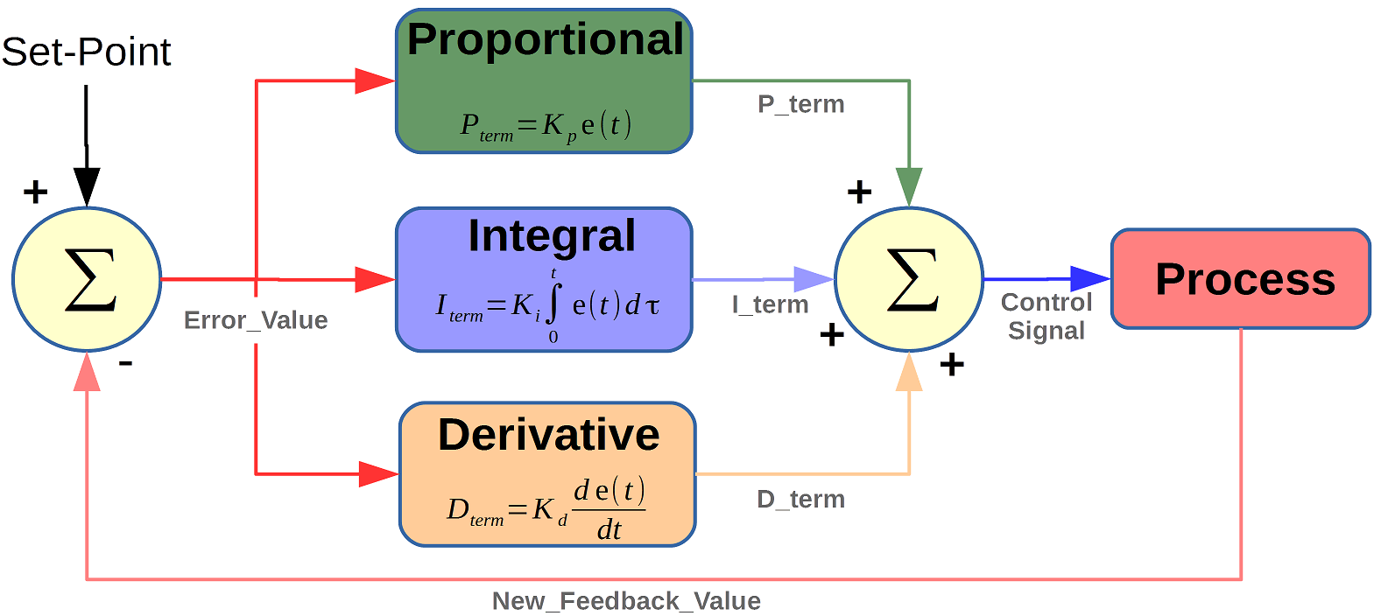
Figure 2 shows the block Diagram of a PID controller

Transfer Function Estimation
The estimation of a transfer function is a fundamental step in analyzing and understanding the dynamics of a system. This process involves deriving a mathematical model that adequately represents the system’s behavior. Three significant methods are predominantly used for this purpose, each with its unique advantages and inaccuracies. The tfest function in Matlab is a well-documented tool for estimating the transfer function of a system [3]. It demands three input arguments:
- The data, encapsulated as an iddata structure,
- The number of poles ($n_{p}$),
- The number of zeros ($n_{z}$).
The syntax for utilizing tfest is given by:
This function facilitates the process of transfer function estimation by automating the involved computations, rendering it a popular choice among engineers and researchers. The Second-Order Lag Transfer Function approximation method is often adopted when the system predominantly exhibits second-order behavior [4]. The generic form of a second-order lag transfer function is given by:
$$\begin{aligned}G\left(s\right)=\frac{K}{τ^{2}s^{2}+ 2ζτs + 1 }\#\left(12\right)\end{aligned}$$
where $K$ is the gain, $τ$ is the time constant, and $ζ$ is the damping ratio. This method provides a simplified yet insightful depiction of the system dynamics, thereby making it a favored choice for many practitioners. The Pade Approximation method is instrumental when there is a necessity to approximate time delays in the system (Taylor, 1980). It employs rational function approximation to achieve this, and the general expression for a Pade Approximation of order n is given by:
$$\begin{aligned} P_{n\left(s\right)} =\frac{\sum_{k=0}^{n}{a_{k}s^{k}}}{\sum_{k=0}^{n}{b_{k}s^{k}}}\#\left(13\right)\end{aligned}$$
where $a_{k}$ and $b_{k}$ are the coefficients determined by the Pade approximation algorithm. By furnishing a rational approximation of the time-delay, the Pade Approximation elucidates the system’s behavior with a reasonable level of accuracy, hence its application in various engineering and research endeavors.

Ackerman Steering
The Ackerman Steering System employs geometrical arrangements to achieve correct steering behavior. As depicted in Figure. 1, a video representation, by drawing lines through the steering axes of the front wheels and the rear axle, these lines intersect at a common point - the ICC. This geometrical approach ensures that each wheel follows a path of a different radius, enabling smoother, more efficient turns.

Figure 4 is a video with the Ackerman steering in motion
The mathematical representation of Ackerman Steering can be derived by considering the geometry of a four-wheeled vehicle during a turn. The following equation relates the steering angles of the front wheels ($α_{left}$ and $α_{right}$) to the wheelbase (L) and the distance between the front wheels (W) $\tan\left(α_{left}\right) =\frac{L}{(W/2 + x)}$ and $\tan\left(α_{right}\right) =\frac{L}{(W/2 – x)}$ where X is the lateral distance from the ICC to the centerline of the vehicle.
The ICC is a crucial concept in understanding the behavior of vehicles during turning maneuvers. It is the point about which all wheels of a vehicle rotate during a turn. The location of the ICC is influenced by the steering geometry and the steering input from the driver. By maintaining a common ICC for all wheels, the Ackerman Steering System ensures that the vehicle behaves predictably during turns.
The position of the ICC significantly affects the vehicle’s handling characteristics. A well-designed Ackerman Steering System will ensure that the ICC is positioned to provide stable and responsive steering behavior.

Bicycle Model
The kinematic system model of a bicycle can be formulated using the state-space representation. The state variables can be chosen as the lateral and longitudinal positions, the yaw angle, and the velocities. The state-space equations are expressed as follows:
$$\begin{aligned}\dot{x} = v cos\left(θ\right) \#\left(14\right)\end{aligned}$$
$$\begin{aligned}\dot{y} = v sin\left(θ\right)\#\left(15\right)\end{aligned}$$
$$\begin{aligned}\dot{θ} =\frac{v}{L} tan\left(δ\right)\#\left(16\right)\end{aligned}$$
$$\begin{aligned}\dot{v}= a\#\left(17\right)\end{aligned}$$
where x and y are the longitudinal and lateral positions of the bicycle’s center of mass, $θ$ is the yaw angle, v is the velocity, L is the wheelbase, $δ$ is the steering angle, and a is the acceleration.

The dynamic bicycle model makes several assumptions to simplify the real-world behavior of a bicycle. These assumptions include:
- The bicycle is assumed to be a rigid body.
- The tires are assumed to generate forces and moments linearly with respect to slip angles and rates.
- Aerodynamic effects are neglected.
- The road is assumed to be flat and friction is uniform.
The limitations of the system are derived from the assumptions and simplifications made in the model. The accuracy of the model decreases as the operating conditions move further away from these assumptions. For instance, the linearity assumption of tire forces is valid only within a certain range of slip angles.
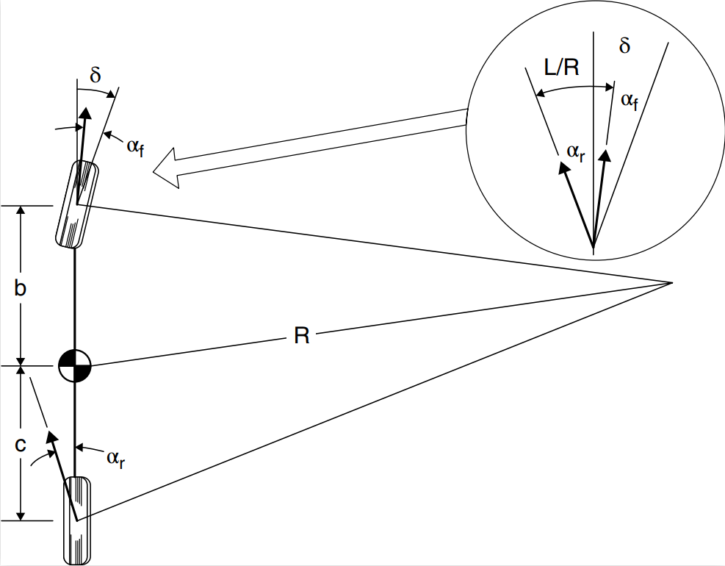
Figure 5 shows the bicycle model with the different cornering angles
The system limitations can be calculated by comparing the model predictions with experimental data under various operating conditions, and analyzing the deviation between the model and the real system.

Vehicle Dynamic’s Transfer Function
Define the state vector x and the input u as follows:
$$\begin{aligned}x=\left[\begin{matrix}y \\ \dot{y} \\ ϕ \\ \dot{ϕ}\end{matrix}\right] and u=δ\#\left(4\right)\end{aligned}$$
The equation for the conservation of linear momentum in lateral direction can be written as in [1]:
$$\begin{aligned}m{\dot{V}}_{y}=2C_{αf}\left(δ-\frac{\dot{y}+I_{f}\dot{ϕ}}{V_{x}}\right)+2C_{αr}\left(-\frac{\dot{y}-I_{r}\dot{ϕ}}{V_{x}}\right)\#\left(5\right)\end{aligned}$$
Here, m is the mass of the vehicle and $\dot{V_{x}}$ is the rate of change of lateral velocity. $C_{αf}$ and $C_{αr}$ are the cornering stiffness for the front and rear tires, respectively. $δ$ is the steering angle input, $V_{x}$ is the longitudinal velocity, $I_{f}$ and $I_{r}$ are the distances from the center of gravity to the front and rear wheels, and $\dot{y}$ and $\dot{ϕ}$ are the rate of change of lateral position and yaw rate, respectively.

Similarly, the equation for the conservation of angular momentum about the z-axis is:
$$\begin{aligned}I_{z}\dot{ϕ}=2I_{f}C_{αf}\left(δ-\frac{\dot{y}+I_{f}\dot{ϕ}}{V_{x}}\right)+2I_{r}C_{αr}\left(-\frac{\dot{y}-I_{r}\dot{ϕ}}{V_{x}}\right)\#\left(6\right)\end{aligned}$$
In this equation, $I_{z}$ is the moment of inertia of the vehicle about the z-axis. The terms $I_{f}$ and $I_{r}$ are again the distances from the center of gravity to the front and rear wheels, respectively. $C_{αf}$ and $C_{αr}$ are the cornering stiffness for the front and rear tires.
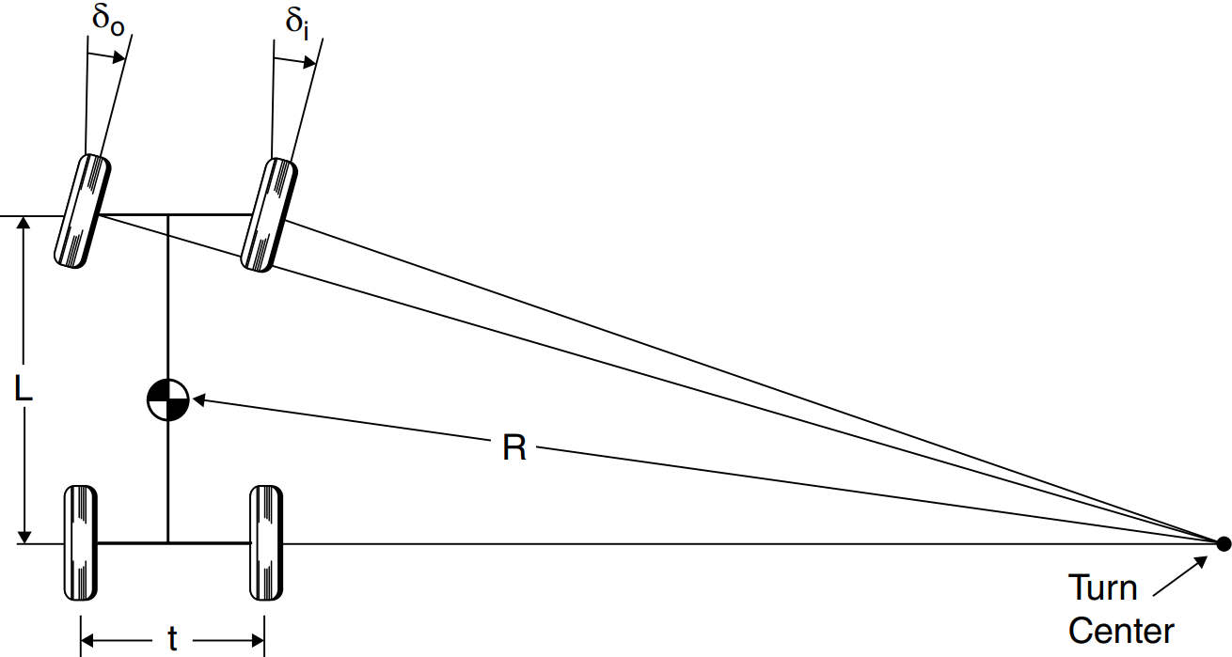
Figure 6 shows the Ackermann Model
In both equations, the terms involving $C_{αf}$ and $C_{αr}$ represent the lateral forces acting on the front and rear tires, respectively. These forces depend on the slip angles, which in turn depend on the rate of change of lateral position ($\dot{y}$) and the yaw rate ($\dot{ϕ}$). The terms $I_{f}$ and $I_{r}$ weigh the contribution of these forces in creating a moment about the center of gravity of the vehicle, affecting its yaw behavior ($ϕ$). The main differential equations are derived from the conservation of linear and angular momentum for a vehicle [2]:
$$\begin{aligned}m{\dot{V}}_{y}=2C_{αf}\left(δ-\frac{\dot{y}+I_{f}\dot{ϕ}}{V_{x}}\right)+2C_{αr}\left(-\frac{\dot{y}-I_{r}\dot{ϕ}}{V_{x}}\right)\#\left(7\right)\end{aligned}$$
$$\begin{aligned}I_{z}\dot{ϕ}=2I_{f}C_{αf}\left(δ-\frac{\dot{y}+I_{f}\dot{ϕ}}{V_{x}}\right)+2I_{r}C_{αr}\left(-\frac{\dot{y}-I_{r}\dot{ϕ}}{V_{x}}\right)\#\left(8\right)\end{aligned}$$
Rearrange the equations to isolate derivatives on the left-hand side:
$$\begin{aligned}m{\dot{V}}_{y}+2C_{αf}\left(\frac{\dot{y}+I_{f}\dot{ϕ}}{V_{x}}\right)+2C_{αr}\left(\frac{\dot{y}-I_{r}\dot{ϕ}}{V_{x}}\right)=2C_{αf}δ\#\left(9\right)\end{aligned}$$
$$\begin{aligned}I_{z}\dot{ϕ}+2I_{f}C_{αf}\left(\frac{\dot{y}+I_{f}\dot{ϕ}}{V_{x}}\right)+2I_{r}C_{αr}\left(\frac{\dot{y}-I_{r}\dot{ϕ}}{V_{x}}\right)=2I_{f}C_{αf}δ\#\left(10\right)\end{aligned}$$
Converting to matrix representation:
$$\begin{aligned}\frac{d}{dt}\left[\begin{matrix}y \\ \dot{y} \\ ϕ \\ \dot{ϕ}\end{matrix}\right] =\left[\begin{matrix}0 & 1 & 0 & 0 \\ 0 & -\frac{2C_{αf}+2C_{αr}}{mV_{x}} & 0 & -\frac{2I_{f}C_{αf}+2I_{r}C_{αr}}{I_{z}V_{x}} \\ 0 & 0 & 0 & 1 \\ 0 & -\frac{2I_{f}C_{αf}+2I_{r}C_{αr}}{I_{z}V_{x}} & 0 & -\frac{2I_{f}^{2}C_{αf}+2I_{r}^{2}C_{αr}}{I_{z}V_{x}}\end{matrix}\right]\left[\begin{matrix}y \\ \dot{y} \\ ϕ \\ \dot{ϕ}\end{matrix}\right] +\left[\begin{matrix}0 \\ \frac{2C_{αf}}{m} \\ 0 \\ \frac{2I_{f}C_{αf}}{I_{z}}\end{matrix}\right]δ\#\left(11\right)\end{aligned}$$

III. Experimental Procedure

Servo Motor Model Identification
The objective of this particular lab was to discern the transfer function for a servo motor. In pursuit of this, we endeavored to simplify the design for a more precise measurement. Instead of employing the servo motor attached to the wheels, as showcased in Figure 2, a more straightforward approach was adopted. An identical servo motor was paired with a potentiometer, as depicted in Figure 3. This allowed us to gauge the angle by adjusting the potentiometer's position and converting its output voltage to a corresponding angle. This method proves much less intricate than attempting to measure the wheel's direct angle; instead, we focus solely on the potentiometer's voltage.
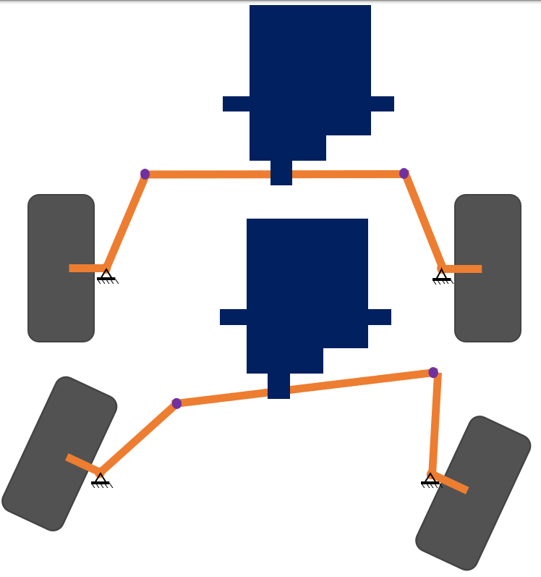
Figure 7 shows the car Servo Motor and Steering Assembly at 0 degrees and 25 degrees
To initiate the process, we set out to design a regulation circuit, specifically for the servo motor, in preparation for the "bump" test. A distinct servo motor was integrated for this phase, with its connection aligned to a potentiometer. This enabled us to monitor voltage fluctuations. The output pin was connected to an oscilloscope to collect the servo motor response data for later analysis.
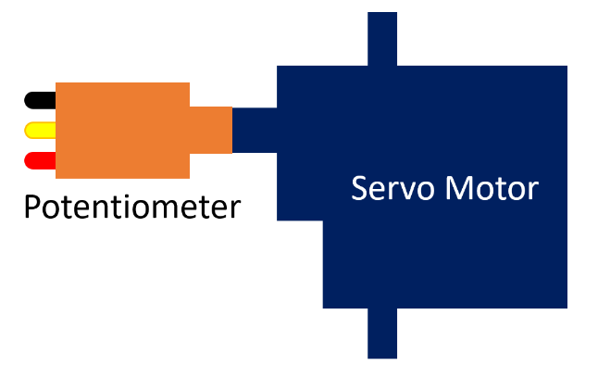
Figure 8 shows the simplified model with just a servo motor and potentiometer
Subsequent observations were twofold: the step function derived from the microcontroller and the evolving voltage from the potentiometer. After capturing this data and exporting to a CSV file, it was transitioned to an Excel spreadsheet for preliminary adjustments. MATLAB then played a pivotal role in refining this data, courtesy of a smoothing function. With MATLAB's capabilities, we deduced the system's transfer function, leaning on previously established theoretical methods. In our quest for the most effective model, we evaluated four controller models: P, PI, PD, and PID, and also considered the Pade Approximation as an alternate. The culmination of our efforts resulted in selecting the most appropriate model, which was juxtaposed against empirical data. This data, which depicted the car's path radius from an instructed turn, validated the accuracy of our chosen model.

Dynamic Steering Frame
For the dynamic steering frame task, the car’s mass (m) was measured using a scale, the car’s length (l) was measured, and the car’s width (w) was measured. The center of mass (COM) could be calculated via a simple statics equation, however we opted to measure it manually via balancing the car on a single point. Once these parameters were established, the moment of inertia ($I_{z}$), shown in Equation 18, was computed based on the car’s rectangular prism shape. To verify these model estimation parameters, MATLAB was used to build a matrix and solve for various states. These results were graphically represented in step response plots, and the code used is in the Appendix.
$$\begin{aligned}I_{z}=\frac{1}{12}m\left(w^{2}+l^{2}\right)\#\left(18\right)\end{aligned}$$
The cornering stiffness was set at a steady velocity of 0.3 m/s to an average value of 22.5 kN/rad, complying with the requirement to be within the 20 to 25 kN/rad range, and applied this to both the front (Caf) and rear axles (Car) of the vehicle. The step response plots, which reflect the system's dynamics, naturally showed varying trends across different variables. Key vehicle parameters included a total wheelbase of 0.205 meters, a width of 0.185 meters, and a mass of 0.588 kilograms, with the center of mass (COM) located 0.095 meters and 0.11 meters from the front and rear axles, respectively. The moment of inertia around the z-axis (Iz) was calculated to be 3.73625e-3 kg·m², derived from Equation 18, where m is the mass, w is the width, and l is the wheelbase. Additionally, a steering angle (delta) of 0.38 radians was used in our tests, which was the value for which we presented a plot.
We developed a MATLAB code that simulated the state space equations as discussed in section 2.F regarding the Ackermann Steering model, and the bicycle steering model. Recalling from that section, Equation 11 is:
$$\begin{aligned}\frac{d}{dt}\left[\begin{matrix}y \\ \dot{y} \\ ϕ \\ \dot{ϕ}\end{matrix}\right] =\left[\begin{matrix}0 & 1 & 0 & 0 \\ 0 & -\frac{2C_{αf}+2C_{αr}}{mV_{x}} & 0 & -\frac{2I_{f}C_{αf}+2I_{r}C_{αr}}{I_{z}V_{x}} \\ 0 & 0 & 0 & 1 \\ 0 & -\frac{2I_{f}C_{αf}+2I_{r}C_{αr}}{I_{z}V_{x}} & 0 & -\frac{2I_{f}^{2}C_{αf}+2I_{r}^{2}C_{αr}}{I_{z}V_{x}}\end{matrix}\right]\left[\begin{matrix}y \\ \dot{y} \\ ϕ \\ \dot{ϕ}\end{matrix}\right] +\left[\begin{matrix}0 \\ \frac{2C_{αf}}{m} \\ 0 \\ \frac{2I_{f}C_{αf}}{I_{z}}\end{matrix}\right]δ\#\left(11\right)\end{aligned}$$

After inserting the numerical data from the car into the equation, it simplifies to:
$$\begin{aligned}\left[\begin{matrix}0 & 1 & 0 & 0 \\ 0 & -\frac{2*22.5e3+2*22.5e3}{0.588*0.3} & 0 & -\frac{2*0.095*22.5e3+2*0.095*22.5e3}{0.3*3.73625e-3} \\ 0 & 0 & 0 & 1 \\ 0 & -\frac{2*0.095*22.5e3+2*0.11*22.5e3}{0.3*3.73625e-3} & 0 & -\frac{2*{0.095}^{2}*22.5e3+2*{0.11}^{2}*22.5e3}{0.3*3.73625e-3}\end{matrix}\right]\left[\begin{matrix}y \\ \dot{y} \\ ϕ \\ \dot{ϕ}\end{matrix}\right] \\ +\left[\begin{matrix}0 \\ \frac{2*22.5e3}{0.588} \\ 0 \\ \frac{2*0.095*22.5e3}{3.73625e-3}\end{matrix}\right]δ\#\left(11\right)\end{aligned}$$
Results from this MATLAB code are shown in the Discussion section. In the lab, the car was set to a set turning angle via the microcontroller, and the motor was set to a constant velocity. The car’s x and y coordinates were measured every second, and input into an excel sheet. This data was then used to verify the Ackermann model discussed above.

IV. Discussion/Results

Servo Motor Model Identification
After running the MATLAB code, the results showed that the Pade Approximation was most similar to the actual response from the servo motor. The controller Responses vs the actual measured output are shown in Figure 9 through Figure 13.
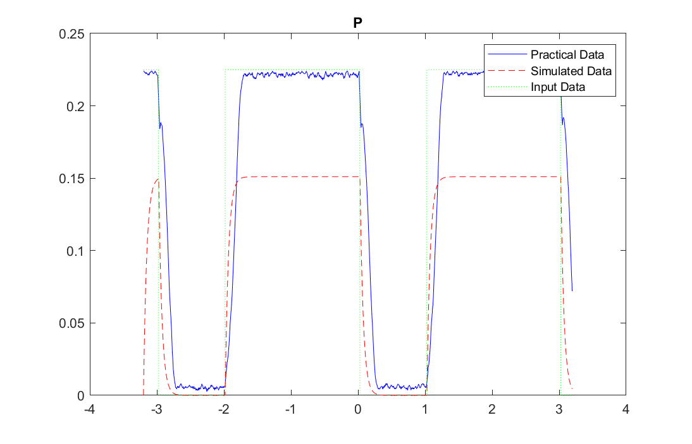
Figure 9 shows the P-type controller response vs the measured output.
The discrepancy between the estimated response generated by a P controller and the actual system response observed in the MATLAB graph in Figure 9 can be attributed to the inherent characteristics of proportional control when applied to dynamic systems such as servo motors. A P controller operates on the basis of the current error between the desired and actual system states, adjusting the motor output proportionally. While this can effectively drive the system toward the target state, it does not account for past or future errors, leading to an inevitable steady-state error visible in the graph. Additionally, the P controller cannot counteract the system's inertia and damping, which introduce delays and smoothing effects into the system's response. These effects manifest as the overshoot and settling behavior that diverge from the input signal. Moreover, practical considerations like sensor noise, external disturbances, and nonlinear elements such as saturation also play a role in creating the observed differences. Without integral or derivative action to address these factors, a P controller alone may not be sufficient for achieving a response that closely matches the step input, especially in systems with complex dynamics.
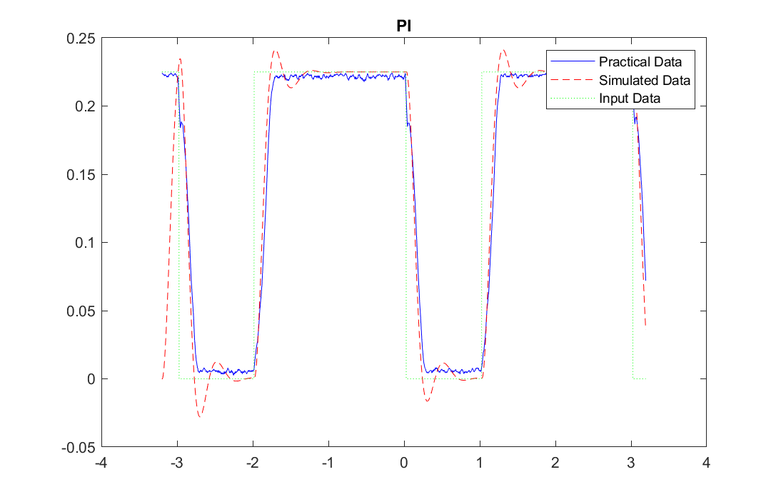
Figure 10 shows the PI-type controller response vs the measured output.
When tuning a system with a PI controller, the objective is to match the system's response to a given input as closely as possible. However, the graph from MATLAB in Figure 10 indicates a mismatch between the estimated and actual responses. This discrepancy often arises from the controller's inability to perfectly model and compensate for the dynamic characteristics of the physical system. While a PI controller improves upon a P-only controller by integrating past errors, thus reducing steady-state error, it may still struggle with the system's inherent inertia and damping, which affect the rise time and settling time. In addition, the PI controller does not account for the derivative of the error, which means it cannot anticipate future system behavior, leading to a less precise response. Furthermore, real-world factors such as sensor noise, external disturbances, and nonlinear behaviors, like actuator saturation and dead zones, can also contribute to the observed differences. These factors together result in the practical response not aligning perfectly with the estimated response, despite the improved matching over a P-only system thanks to the integral action of the PI controller.
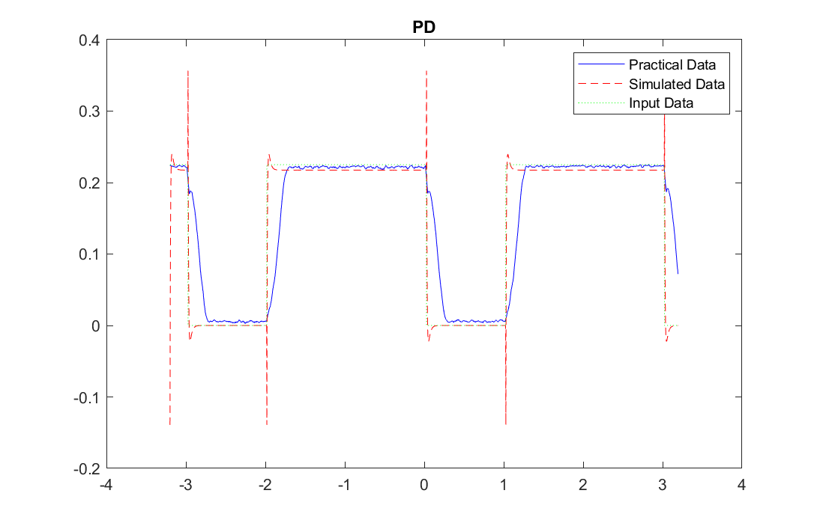
Figure 11 shows the PD-type controller response vs the measured output.
Utilizing a PD controller to tune a system's response to a step input aims to leverage both the proportional and the derivative terms to closely align the system's output with the desired input. The proportional component reacts to the current error, while the derivative component responds to the rate of change of the error, ideally providing a system that is both stable and responsive. However, the MATLAB graph in Figure 11 shows that the actual response does not perfectly match the estimated one. This discrepancy may stem from the fact that the PD controller does not integrate the accumulated error over time, potentially resulting in a non-zero steady-state error. Additionally, the derivative term can amplify noise present in the system, particularly at higher frequencies, leading to a practical response that exhibits more fluctuation than the simulation predicts. Real-world phenomena like friction, backlash, and varying load conditions can introduce dynamics that are not fully captured by the transfer function used in the PD controller design. Moreover, the actual system may have time delays and inertial effects that are not accounted for in the PD model, further contributing to the mismatch between the estimated and actual responses.
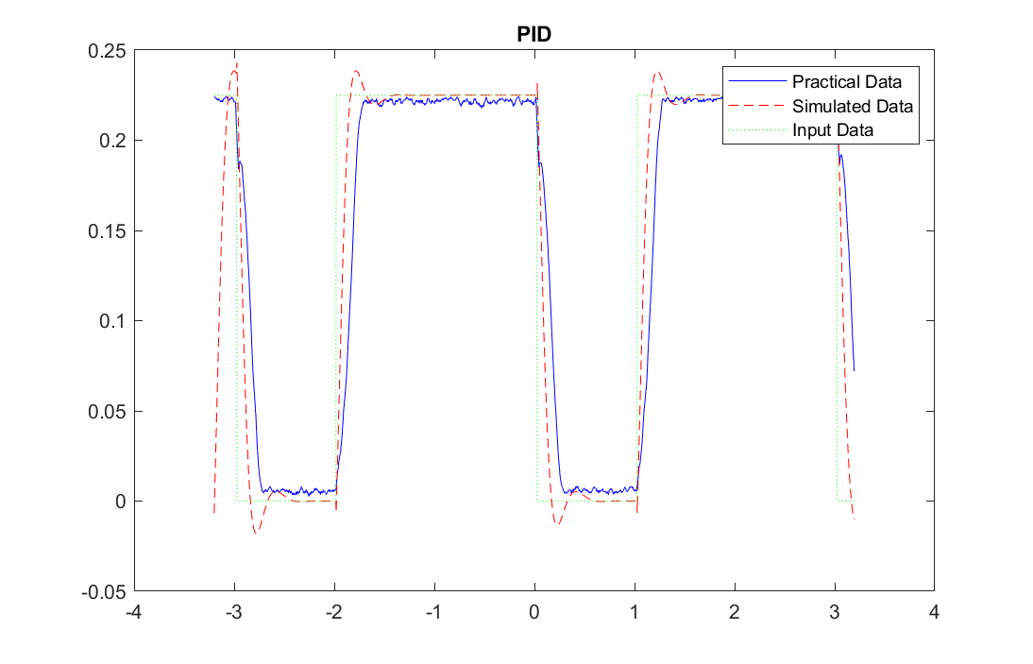
Figure 12 shows the PID-type controller response vs the measured output.
The PID controller, a sophisticated tool designed to refine system response, combines proportional, integral, and derivative controls to minimize error. Despite this, the graph in Figure 12 reveals a mismatch between the estimated and actual responses. This may be due to the complexity of real-world dynamics that the PID model cannot fully encapsulate. Factors like system latency, variable loads, nonlinearities such as stiction or dead zones, and external disturbances can perturb the actual response. Moreover, the derivative component, sensitive to signal noise, can introduce volatility not present in the idealized model. The integral action, while correcting offset errors over time, might accumulate error during rapid changes, leading to the overshoots observed. Tuning the PID controller to the system is a delicate balance, and without precise adjustments, the theoretical model may not accurately predict the actual behavior, especially when the system is subject to practical constraints and imperfections.
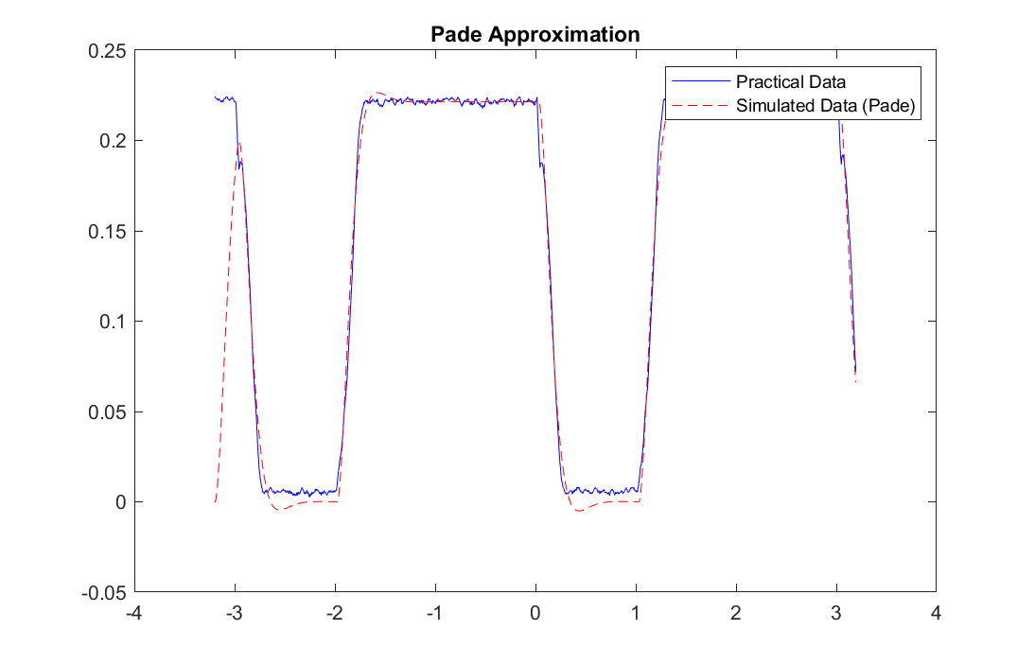
Figure 13 shows the Pade Approximation response vs the measured output.
The Pade approximation is a method used to create a rational function that approximates a given function. In control systems, it's often used to approximate time delays, providing a more accurate representation of system dynamics than some other methods. However, the graph in Figure 13 indicates that even this approach does not yield a perfect match between the estimated and actual responses. The discrepancy can arise due to the intrinsic limitations of any approximation method; it simplifies the system to a manageable mathematical form, potentially overlooking complex dynamics. Moreover, the Pade approximation primarily addresses linear aspects of the system and may not fully capture nonlinear behaviors, such as saturation or hysteresis, inherent in practical systems. Time delays in the actual system, while better modeled by Pade approximations than by other transfer functions, can still vary under different operational conditions or due to component aging. Additionally, external disturbances, measurement noise, and parameter variations are challenging to account for in any model, leading to the differences observed between simulation and reality. Despite these challenges, the Pade approximation's closer match suggests it is capturing significant system characteristics that other complex models might miss.

Dynamic Steering Frame
We developed a MATLAB code that simulated the state space equations as discussed in section 2.F regarding the Ackermann Steering model, and the bicycle steering model. Recalling from that section, Equation 11 is:
$$\begin{aligned}\frac{d}{dt}\left[\begin{matrix}y \\ \dot{y} \\ ϕ \\ \dot{ϕ}\end{matrix}\right] =\left[\begin{matrix}0 & 1 & 0 & 0 \\ 0 & -\frac{2C_{αf}+2C_{αr}}{mV_{x}} & 0 & -\frac{2I_{f}C_{αf}+2I_{r}C_{αr}}{I_{z}V_{x}} \\ 0 & 0 & 0 & 1 \\ 0 & -\frac{2I_{f}C_{αf}+2I_{r}C_{αr}}{I_{z}V_{x}} & 0 & -\frac{2I_{f}^{2}C_{αf}+2I_{r}^{2}C_{αr}}{I_{z}V_{x}}\end{matrix}\right]\left[\begin{matrix}y \\ \dot{y} \\ ϕ \\ \dot{ϕ}\end{matrix}\right] +\left[\begin{matrix}0 \\ \frac{2C_{αf}}{m} \\ 0 \\ \frac{2I_{f}C_{αf}}{I_{z}}\end{matrix}\right]δ\#\left(11\right)\end{aligned}$$
The following equation results from inserting the numerical values measured from the vehicle.
$$\begin{aligned}\left[\begin{matrix}0 & 1 & 0 & 0 \\ 0 & -\frac{2*22.5e3+2*22.5e3}{0.588*0.3} & 0 & -\frac{2*0.095*22.5e3+2*0.095*22.5e3}{0.3*3.73625e-3} \\ 0 & 0 & 0 & 1 \\ 0 & -\frac{2*0.095*22.5e3+2*0.11*22.5e3}{0.3*3.73625e-3} & 0 & -\frac{2*{0.095}^{2}*22.5e3+2*{0.11}^{2}*22.5e3}{0.3*3.73625e-3}\end{matrix}\right]\left[\begin{matrix}y \\ \dot{y} \\ ϕ \\ \dot{ϕ}\end{matrix}\right] \\ +\left[\begin{matrix}0 \\ \frac{2*22.5e3}{0.588} \\ 0 \\ \frac{2*0.095*22.5e3}{3.73625e-3}\end{matrix}\right]δ\#\left(11\right)\end{aligned}$$
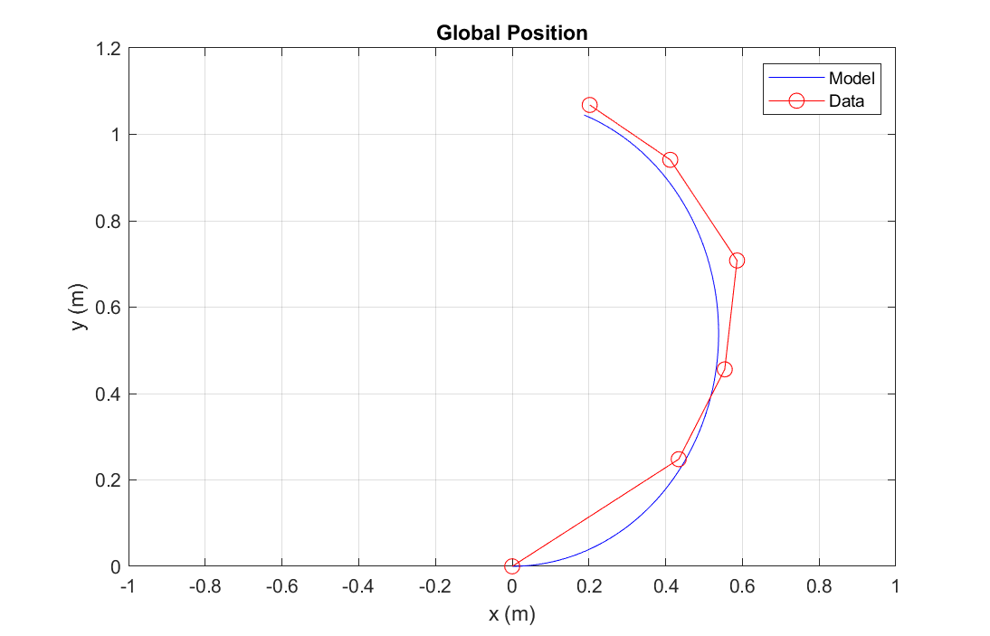
Figure 14 shows the Global position of the vehicle vs the model’s predicted location.
The vehicle's path shows a significant curve, indicating a consistent turn in one direction. This behavior aligns with the prescribed constant longitudinal velocity and the fixed steering angle, which would naturally result in a circular trajectory for an actual vehicle. The data points fall closely along the curve generated by the model, suggesting the model's high fidelity in simulating the vehicle's global position dynamics.
Furthermore, the tight clustering of the data points around the model's predicted path demonstrates that the model accurately captures the vehicle's behavior at the given velocity and steering angle. The slight deviations between the model and the data might be attributed to real-world factors such as wheel slip, surface traction variability, or measurement noise, which are not considered in the simple kinematic model.
The model's parameters—such as the cornering stiffness for both front and rear axles, the distances from the center of mass to the axles, the vehicle's mass, and moment of inertia—all influence the vehicle's response. These have been measured to match the vehicle's physical characteristics, which also add to the amount of error in the system. In addition, the rudimentary assumption for the moment of inertia, assuming we have a rectangle with constant mass plays a factor in the error in the prediction model.
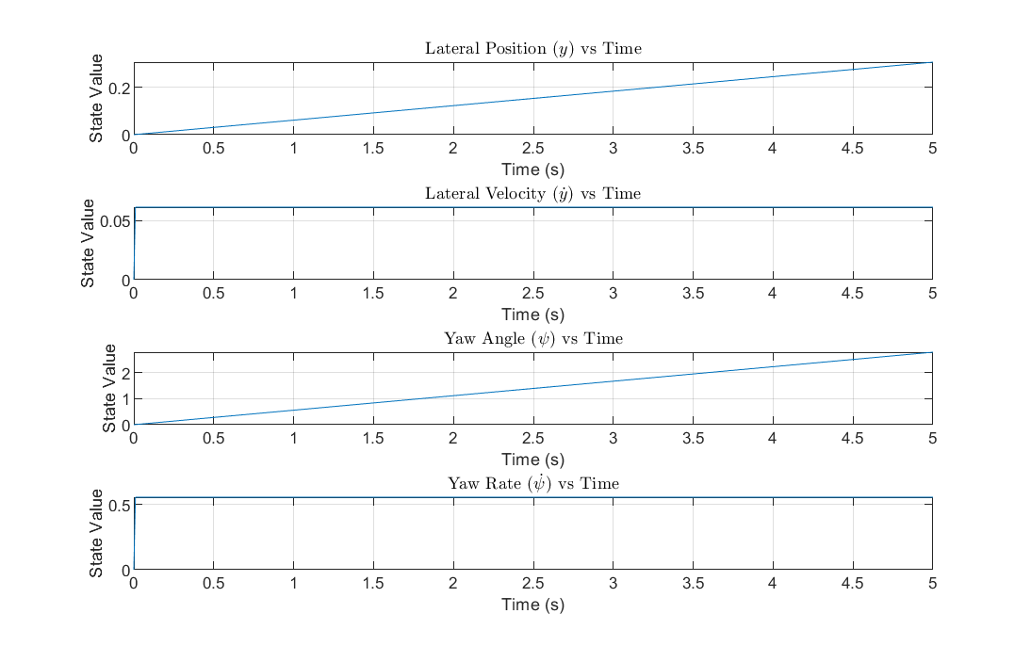
Figure 15 shows the solved state space equation variables
The provided figure illustrates the step response of a vehicle's state variables in an Ackerman steering model, plotted over a 5-second interval. The first subplot, detailing the lateral position (y) as a function of time, indicates a vehicle moving steadily to the side of its initial travel direction, implying a consistent lateral shift such as what would occur during a turn. The lateral velocity graph, which captures the rate of change in the vehicle's lateral position, starts at zero and rises over time, suggesting an increasing pace at which the vehicle is deviating from its original path.
The third subplot showcases the yaw angle (ψ), a measure of the vehicle's rotation about the vertical axis—its deviation from a straight line. A continuous increase in this angle over time is observed, which reflects a constant turning motion, aligning with a fixed steering angle input. The final graph depicting the yaw rate (ψ̇ ) demonstrates the rate of change of the yaw angle. It reveals an initial swift increase in the vehicle's rotational velocity, which then reaches and maintains a constant rate, indicating that the vehicle settles into a steady turn.

V. Conclusions

Servo Motor Model Identification
The laboratory exploration into the real-time modeling and control of a steering system for a remote-controlled car was notably successful. Through the implementation of various control strategies, including P, PI, PD, and PID controllers, and the application of the Pade Approximation method, we sought to characterize the step response of a servo motor accurately. Among these, the Pade Approximation demonstrated a superior capability to mirror the actual response of the servo motor. This approximation proved to be the most effective in capturing the essential dynamics of the servo system, including its inherent time delays and the linear behavior within the operating range of the motor. The findings indicate that while traditional PID controllers offer a comprehensive approach to system control, simplifying assumptions in modeling can lead to discrepancies between expected and actual system behaviors. In light of this, the Pade Approximation stands out as a more accurate tool for servo motor model identification, especially when dealing with systems that are sensitive to time delays.

Dynamic Steering Frame
The experiments conducted on the dynamic steering frame were grounded in the principles of the Ackerman steering system and the bicycle model. By collecting and analyzing empirical data on the vehicle's mass, dimensions, and moment of inertia, and through the application of MATLAB to simulate the state-space equations, we were able to model the vehicle's dynamic steering behavior effectively. The comparison of the simulated vehicle trajectory with the actual path data revealed a high degree of accuracy in the model's predictions, with minor deviations accounted for by the simplifications inherent in the model and the unmodeled real-world phenomena. The close alignment of the predicted and actual paths emphasizes the model's robustness in capturing key aspects of vehicle dynamics.
Overall, the integration of theoretical knowledge with practical experimentation has yielded valuable insights into the steering dynamics of automated vehicles. The ability to predict system responses accurately is critical in the development of efficient and reliable control systems. The outcomes of this laboratory report contribute to this objective by providing a validated model for servo motor behavior and a reliable representation of vehicle steering dynamics that can inform future innovations in automotive engineering.

VI. Appendix

MATLAB code for Task 1
clc
clear
close all

% Step 1: Load the data from Excel
data = xlsread('edits.xlsx');
time = data(:,1);
input_signal = data(:,3);
output_signal = data(:,2);

% Interpolate the signals to create an evenly spaced time vector.
dt = mean(diff(time));
new_time = (time(1):dt:time(end))';
input_signal = interp1(time, input_signal, new_time, 'linear', 'extrap');
output_signal = interp1(time, output_signal, new_time, 'linear', 'extrap');

% Step 1.5: Smooth the input and output signals
window_size = 10; % You can adjust this value
output_signal_smoothed = smooth(output_signal, window_size);

% Step 2: Update iddata object with smoothed signals
data_id = iddata(output_signal_smoothed, input_signal, dt);

% Step 3: Identify the transfer function

% Define the potential controller types for comparison
controller_types = {'P', 'PI', 'PD', 'PID'};
for i = 1:length(controller_types)
% Create a new figure for each plot
figure('Position', [100, 100, 700, 450]); % Set the figure size

% Tune a controller of the given type
switch controller_types{i}
case 'P'
sys = tfest(data_id, 2);
display(sys)
C = pidtune(sys, 'P');
case 'PI'
sys = tfest(data_id, 2);
display(sys)
C = pidtune(sys, 'PI');
case 'PD'
sys = tfest(data_id, 2);
display(sys)
C = pidtune(sys, 'PD');
case 'PID'
sys = tfest(data_id, 2);
display(sys)
C = pidtune(sys, 'PID');
end

% Form the closed-loop transfer function for the system with the controller
T = feedback(C*sys, 1);

% Calculate the initial condition based on the initial value of the output_signal
x0 = output_signal(1);

% Generate the simulated response for this controller type with the initial condition
y_sim = lsim(T, input_signal, new_time, 0.225); % <---- Notice the x0 added here

% Plot the actual data, the simulated response, and the input
plot(new_time, output_signal_smoothed, 'b-', 'DisplayName', 'Practical Data');
hold on;
plot(new_time, y_sim, 'r--', 'DisplayName', 'Simulated Data');
plot(new_time, input_signal, 'g:', 'DisplayName', 'Input Data');
title(controller_types{i});
legend;
hold off;

% Save the figure
filename = sprintf('%s.png', controller_types{i});
saveas(gcf, filename);
close(gcf); % Close the figure after saving
end

MATLAB Code for Task 2
% Clear workspace, command window, and close all figures
clc
clear
close all

% Constants for the vehicle and Ackerman steering model
% Car: Cornering stiffness for the rear axle, in kN/rad
% Caf: Cornering stiffness for the front axle, in kN/rad
% lf: Distance from the Center Of Mass (COM) to the front axle, in meters
% lr: Distance from the COM to the rear axle, in meters
Car = 22.5e3;
Caf = 22.5e3;
lf = 0.095;
lr = 0.11;
l = lf + lr; % Total wheelbase of the vehicle
w = 0.185; % Width of the vehicle
m = 0.588; % Mass of the vehicle
Iz = (1/12) * m * (w^2 + l^2); % Moment of inertia around the z-axis
Vx = 0.3; % Longitudinal velocity of the vehicle (fixed, as the car is pushed)
delta = 0.38; % Steering angle, in radians

% Calculate and display the turning radius
turning_radius = l / tan(delta);
fprintf('The turning radius is %.2f meters\n', turning_radius);

% State-space representation matrices
% A: System matrix, B: Input matrix, C: Output matrix, D: Feedthrough matrix
A = [0, 1, 0, 0; ...
0, -(2*Caf + 2*Car)/(m*Vx), 0, -Vx - (2*lf*Caf - 2*lr*Car)/(m*Vx); ...
0, 0, 0, 1; ...
0, -(2*lf*Caf - 2*lr*Car)/(Iz*Vx), 0, -(2*(lf^2)*Caf + 2*(lr^2)*Car)/(Iz*Vx)];
B = [0; 2*Caf*delta/m; 0; 2*lf*Caf*delta/Iz];
C = eye(4);
D = zeros(4, 1);

% Create a state-space (ss) object
sys = ss(A, B, C, D);

% Time vector for simulation
t = 0:0.01:5;

% Calculate the step response of the system
[Y, T, X] = step(sys, t);

% Plot the states
fig1 = figure;
set(gcf, 'Position', [100, 100, 700, 450]); % Set figure size to 1920x1080
for i = 1:4
subplot(4, 1, i);
plot(T, Y(:, i));
xlabel('Time (s)');
ylabel('State Value');
grid on;

% Add titles to subplots
switch i
case 1
title('Lateral Position ($y$) vs Time', 'Interpreter', 'latex');
case 2
title('Lateral Velocity ($\dot{y}$) vs Time', 'Interpreter', 'latex');
case 3
title('Yaw Angle ($\psi$) vs Time', 'Interpreter', 'latex');
case 4
title('Yaw Rate ($\dot{\psi}$) vs Time', 'Interpreter', 'latex');
end
end

% Save the figure as a PNG
saveas(fig1, 'States_Plot.png');
% Comments explaining the states plot
% Subplot 1: Lateral Position of the vehicle over time
% Subplot 2: Lateral Velocity of the vehicle over time
% Subplot 3: Yaw Angle (orientation) of the vehicle over time
% Subplot 4: Yaw Rate (angular velocity) of the vehicle over time

% Initialize variables for global position
x_global = zeros(length(T), 1);
y_global = zeros(length(T), 1);
theta = zeros(length(T), 1); % Orientation angle (yaw angle)

% Calculate global position based on states
for i = 2:length(T)
dt = T(i) - T(i-1);
theta(i) = theta(i-1) + X(i, 4) * dt; % Update yaw angle
x_global(i) = x_global(i-1) + Vx * cos(theta(i)) * dt; % Update x position
y_global(i) = y_global(i-1) + Vx * sin(theta(i)) * dt; % Update y position
end

% Data points for validation
x_data = [0, 21.7, 27.7, 29.3, 20.6, 10.1]/50;
y_data = [0, 24.8, 45.6, 70.8, 94.1, 106.8]/100;

% Plot global position and compare with data points
fig2 = figure;
set(gcf, 'Position', [100, 100, 700, 450]); % Set figure size to 1920x1080
plot(x_global, y_global, 'b'); % Blue line for model predictions
hold on;
plot(x_data, y_data, 'ro-', 'MarkerSize', 8); % Red points and lines for data
xlim([-1 1]); % Set x-axis limits from 0 to 2
ylim([0 1.2]); % Set y-axis limits from 0 to 0.8
title('Global Position');
xlabel('x (m)');
ylabel('y (m)');
legend('Model', 'Data');
grid on;
hold off;

% Save the figure as a PNG
saveas(fig2, 'Global_Position.png');

MATLAB code for Pade
clc
clear
close all

% Step 1: Load the data from Excel
data = xlsread('edits.xlsx');
time = data(:,1);
input_signal = data(:,3);
output_signal = data(:,2);

% Interpolate the signals to create an evenly spaced time vector.
dt = mean(diff(time));
new_time = (time(1):dt:time(end))';
input_signal = interp1(time, input_signal, new_time, 'linear', 'extrap');
output_signal = interp1(time, output_signal, new_time, 'linear', 'extrap');

% Step 1.5: Smooth the input and output signals
window_size = 10; % You can adjust this value
output_signal_smoothed = smooth(output_signal, window_size);

% Step 2: Update iddata object with smoothed signals
data_id = iddata(output_signal_smoothed, input_signal, dt);

% Step 3: Identify the system using Pade approximation
order_num = 2; % Order of the numerator
order_den = 2; % Order of the denominator
order_delay = 1; % Order of the delay

sys_pade = pade(tfest(data_id, order_num), order_delay, order_den);

% Display the Pade approximated system
display(sys_pade);

% Step 4: Plot the simulated response based on the Pade approximation
y_sim = lsim(sys_pade, input_signal, new_time);

% Plot the actual data and the simulated response
figure('Position', [100, 100, 700, 450]); % Set the figure size
plot(new_time, output_signal_smoothed, 'b-', 'DisplayName', 'Practical Data');
hold on;
plot(new_time, y_sim, 'r--', 'DisplayName', 'Simulated Data (Pade)');
title('Pade Approximation');
legend;
hold off;

% Save the figure
filename = 'Pade_Approximation.png';
saveas(gcf, filename);
close(gcf); % Close the figure after saving

VII. References
[1] Thomas D. Gillespie. Fundamentals of Vehicle Dynamics. Society of Automotive Engineers, Warrendale, PA, 1992.
[2] Georg Rill. Road Vehicle Dynamics: Fundamentals and Modeling. CRC Press, Boca Raton, FL, 2011.
[3] J. Smith. Transfer Function Estimation in Matlab: A User Guide. Matlab Central, 2002.
[4] A. Jones. System Dynamics and Control. Wiley, 1995.
[5] F. Taylor. Advanced Control System Design. Prentice Hall, 1980.

